Create an nginx deployment

apiVersion: apps/v1

kind: Deployment

metadata:

name: nginx-deploy

spec:

replicas: 2

selector:

matchLabels:

app: nginx-app

template:

metadata:

labels:

app: nginx-app

spec:

containers:

- image: nginx

name: nginx-container

ports:

- containerPort: 80

*kubectl create -f deployment.yaml*

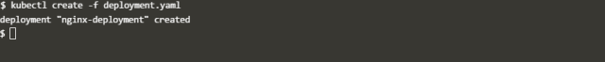

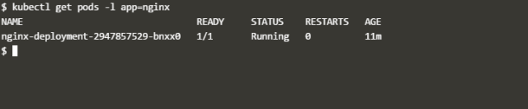

## #Create service

apiVersion: v1

kind: Service

metadata:

name: nginx1-service

spec:

ports:

- port: 80

nodePort: 31333

targetPort: 80

selector:

app: nginx-app

type: NodePort

## #Deploy service

## get Svc command

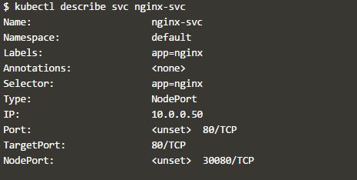

## Update nginx deployment to have 4 replicas

apiVersion: apps/v1

kind: Deployment

metadata:

name: nginx-deploy

spec:

replicas: 4

selector:

matchLabels:

app: nginx-app

template:

metadata:

labels:

app: nginx-app

spec:

containers:

- image: nginx

name: nginx-container

ports:

- containerPort: 80

## Apply the updated nginx deployment to have 4 replicas

## get deployment command

## list of pods created by the deployment

## get Pods command